我們每一個人都是媽媽經過十個月懷胎，辛苦生下的。而在我們生活中媽媽也常默默地為我們做很多事(煮香噴噴的飯給我們吃、幫我們洗衣服…..)而這些事，母親並非是理所當然該替我們做的喔！請你回想從出生到現在，母親所為我們做過的每一件事！
_______________________________________________________________________________________

_______________________________________________________________________________________

_______________________________________________________________________________________

_______________________________________________________________________________________

_______________________________________________________________________________________

_______________________________________________________________________________________

_______________________________________________________________________________________

_______________________________________________________________________________________

_______________________________________________________________________________________

_______________________________________________________________________________________

_______________________________________________________________________________________
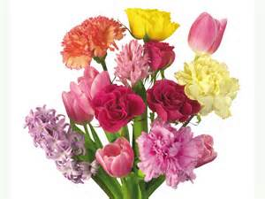
_______________________________________________________________________________________

_______________________________________________________________________________________

_______________________________________________________________________________________

_______________________________________________________________________________________

_______________________________________________________________________________________

_______________________________________________________________________________________

_______________________________________________________________________________________

_______________________________________________________________________________________

_______________________________________________________________________________________

_______________________________________________________________________________________

_______________________________________________________________________________________

_______________________________________________________________________________________

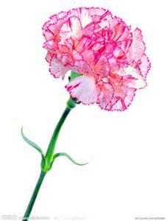
_______________________________________________________________________________________

_______________________________________________________________________________________

_______________________________________________________________________________________

_______________________________________________________________________________________

_______________________________________________________________________________________

_______________________________________________________________________________________
媽媽的感動或鼓勵
媽媽或長輩簽名:
____年____ 班 座號_____ 姓名______________
母親節活動學習單
各位同學:
母親節快到了，你感受到媽媽對你的用心及關懷嗎? 從懷胎十月到養育我們長大、教導我們做人處事的道理，這當中的辛苦說也說不完。趁此佳節，讓我們仔細數數媽媽的好。列滿50點，可以獲得嘉獎一次，列滿100點可獲得嘉獎二次，還可獲得小禮物一份(參加過此活動的同學不再重複獲得嘉獎)。記得要用心體會、親筆繕寫、母親節之前或當天把它送給媽媽當禮物、請媽媽寫下她的感動。有意願完成學習單的同學請至學務處領取，並於5/15(五)前送回訓育組與我們分享!
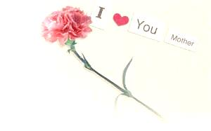
(PS.1.感恩的對象可以是爸爸、你最親近的、或撫養你長大的長輩 2.紙張不夠時請自行增加，也可使用更漂亮的紙張或加以美編設計)

