2026 Kaohsiung Education Festival
7th Annual Conference on Self-Directed Learning
Call for Submissions
- Overview:
The Kaohsiung Education Festival is celebrating its 10th anniversary with the theme “The Light That Changes the World.” As part of this celebration, we are hosting the 7th Annual Conference on Self-Directed Learning.
- A New Era of Learning
In recent years, digital technology has made it easier for students to connect with the world and share ideas globally. Schools now offer more diverse environments where students can explore modern topics like AI, bilingual education, semiconductors, and sustainability (SDGs). These tools empower students to take charge of their own learning.
- A Shared Platform for All Students
This conference is open to Kaohsiung elementary/junior high students and high school students across the country. It is a space for you to:
- Showcase your journey: Share your personal self-directed learning experiences.
- Go Bilingual: In addition to breakout sessions, the opening forum will be held in both Mandarin and English.
- Connect and Inspire: Through interviews and discussions, students and teachers can discover new ways to make learning meaningful.
- Our Mission:
This event is all about celebrating the spirit of independent learning. Our goals are to:
- Build Your Skills: Help you strengthen your creativity, independent thinking, and research abilities.
- Share Your Journey: Provide a stage where you can showcase your hard work and the diverse skills you have picked up along the way.
- Learn Through Dialogue: Use a friendly interview format to help you reflect on and talk about your learning experiences.
- Leading Administrative Units:
- Supervised by: K-12 Education Administration of Ministry of Education
- Hosted by: Education Bureau of Kaohsiung City Government
- Organized by: Kaohsiung Curriculum Development Team of Compulsory Education (KCDTCE)
- Supported by: Kaohsiung Regional Advisory Group for Compulsory Education, Principal and Teacher Professional Development Center, Kaohsiung Curriculum and Instruction Consulting Center, Kaohsiung Municipal Kaohsiung Girls' Senior High School, Kaohsiung Municipal Sanmin Senior High School, Kaohsiung Municipal Chungshan Senior High School, Kaohsiung Municipal Lu Chu Senior High School, Kaohsiung Municipal Cianjhen Senior High School, Kaohsiung Municipal Jhongjheng Senior High School, Kaohsiung Municipal Kaohsiung Industrial High School, Kaohsiung Municipal Kaohsiung Commercial High School, South Office of Inquiry and Practice Promotion Center, Guoguang Laboratory School of NSYSU, National Feng-Hsin Senior High School, National Kaohsiung University of Science and Technology, Center for Teacher Education of NSYSU; Teacher Education and Careers Service of National Kaohsiung Normal University, Teacher Education Center of National Kaohsiung University of Hospitality and Tourism, Rotary International District 3510 Youth Exchange Committee.
- Facilitator: JECTOR
- Agenda:
- Event Day: Saturday, May 23, 2026, 9:30 a.m. to 3:00 p.m.
- Event Location: Kaohsiung Municipal Kaohsiung Girls' Senior High School
Time | Activity |  | Place
09:30-10:00 | Check In |  | Activity Center
10:00-10:20 | Opening Ceremony |  | Activity Center
10:20-11:20 | Opening Forum (Chinese)  Opening Forum (English) |  | Activity Center
11:20-12:00 | Poster Sharing |  | Activity Center
12:00-13:00 | Lunch & Socializing
13:00-13:20 | Each student/team will be interviewed for 15 minutes. | Session A | Breakout classrooms
13:20-13:40 | Each student/team will be interviewed for 15 minutes. | Session B | Breakout classrooms
13:40-14:00 | Each student/team will be interviewed for 15 minutes. | Session C | Breakout classrooms
14:00-14:20 | Each student/team will be interviewed for 15 minutes. | Session D | Breakout classrooms
14:20-14:30 | Break
14:30-15:00 | Closing Ceremony |  | Activity Center
- Event Details:
- Morning Session – Opening Forum and Poster Sharing
- Opening Forum: Outstanding students will be invited to share their self-directed learning journeys in Mandarin or English.
- Poster sharing: We can engage directly with students’ innovations and learning breakthroughs—exploring their projects, understanding their research processes, and appreciating the dedication behind each effort.
- Afternoon Session – In-depth Interviews (see image below)
- Interviews are conducted by professors and teachers with outstanding students, who share their inspiring self-directed learning journeys.
- Breakout classrooms include 10 in Mandarin, 2 in English, 2 for Rotary Youth Exchange students (from USA, Japan, Germany, Brazil, Denmark, France, Mexico, Hungary, Poland, Austria, and India), and 1 dedicated to the Yancheng Milk Tea Festival project showcase.
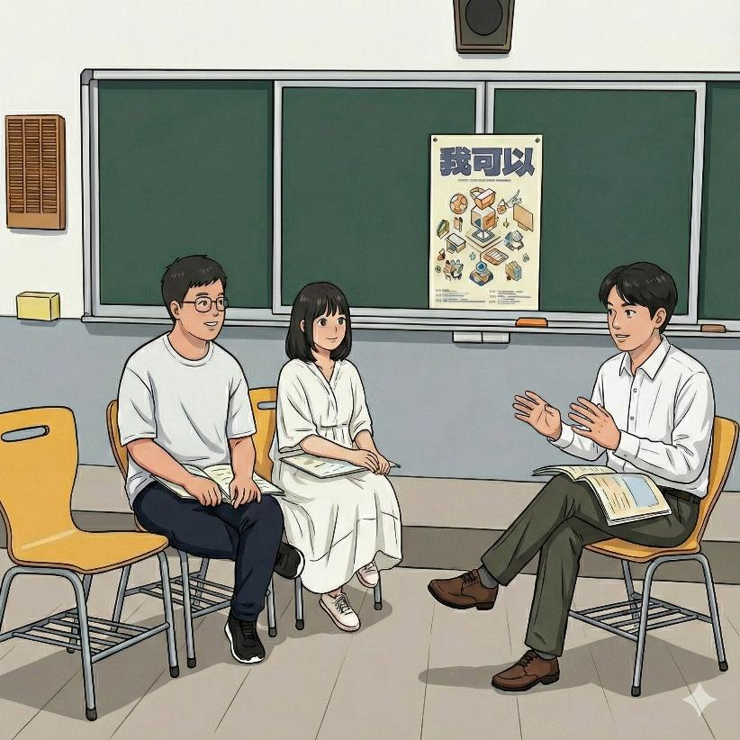
- How to Apply:
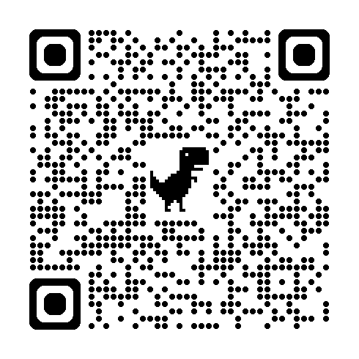
- You can choose any topic that interests you.
- Step 1: Fill out Appendix 1, 2, and 3.
- Step 2: Upload these appendices and photos to the Google Form (https://reurl.cc/OR8eV9).
- Important Note:
  - Open to Kaohsiung elementary/junior high students and high school students across the country. Team members must be from the same school (they may be from different grade levels and different classes). Maximum team members on the same team: 4.
  - You do NOT need to prepare a slideshow for the interview.
- Important dates:
- Application Deadline: Monday, April 20, 2026, by 1:00 p.m.
- Finalists Announced: Thursday, April 30, 2026, at 12:00 p.m. on the official websites of the Education Bureau of Kaohsiung City Government (https://www.kh.edu.tw/) and KCDTCE (https://sites.google.com/view/kcdtce).
- Rewards:
- Recognition: 48 finalists will be selected to have their works published in a special commemorative book, displayed on posters, and shared on the official website of KCDTCE. Each finalist will be invited to present their work at the 2026 Kaohsiung Education Festival’s 7th Annual Conference on Self-Directed Learning.
- Awards: Selected students will receive a Certificate of Excellence from the Education Bureau of Kaohsiung City Government. Students that are not selected will not be notified.
- Faculty and staff who assist in organizing this event will be recognized in accordance with relevant regulations.
- Additional information:
- The Organizer reserves the right to supplement or amend this plan as needed.
- For inquiries related to this conference, please contact Tr. Fang (Tel: 07-3590116 ext. 312) or Ms. Chen (Tel: 07-3590116 ext. 311).
- Please refer to the original Mandarin version of this document if there are any queries or concerns.
Appendix 1
2026 Kaohsiung Education Festival
7th Annual Conference on Self-Directed Learning
Application Form
(One application form for each team)
School Name
Title of Your Work
Language  (Choose one) | □Mandarin □English
Names of Team Members  (Maximum: 4) | - ______________, 2. _____________, 3. _____________, 4. ______________  Note: Open to Kaohsiung elementary/junior high students and high school students across the country. Team members must be from the same school (they may be from different grade levels and different classes.)
Advisor
(optional)
Personal Account of the Journey  (Max: 3 pages) | Guidelines  - Please write in paragraphs, in Mandarin or English.  - Single line spacing, font size 12, English font should be Times New Roman.  - The gray text below represents the five parts of your self-directed learning journey, intended as a guide for your writing.  ………………………(delete the above before submitting)……………………………  Personal account:  - Introduction: Briefly summarize your topic and what you hoped to achieve.  - The Process: Why did you choose this? Describe your journey, the challenges or failures you faced, and how you solved them.  - Outcomes: Share your results and what you think is most important for others to see.  - Reflection: What did you learn about yourself? How will this experience help you in your future studies?  - References: List all sources and AI tools used.
Photos of Your Journey | - Provide at least 5 pictures, each with a brief description below it to help the judges and viewers understand the self-directed learning process.  - Please do so separately on GoogleForm (https://reurl.cc/OR8eV9). Submit the original files of the same photos, each at least 1.2 MB in size, to ensure print quality. (It is recommended that the images have a clear theme to help judges and viewers understand.)
Photos of Your Journey | photo | photo | photo
Photos of Your Journey | description | description | description
Photos of Your Journey | photo | photo
Photos of Your Journey | description | description
Supplementary Evidence | You can attach links to your supporting materials or videos related to the learning outcomes.
AI Usage (if applicable)  (Please disclose honestly.) | A brief description in 100 words of how you used AI (Writing guidelines: Under what circumstances did you use AI? What role did AI play? How did you use or adapt what AI provided? How did you ensure that this work is your own?)

Appendix 2
2026 Kaohsiung Education Festival
7th Annual Conference on Self-Directed Learning
Declaration of Academic Integrity
(One copy for each student)
______________________________________(Title of your work)
By signing this, I guarantee that this work is my own and is free from plagiarism or ghostwriting. I understand that any dishonesty will lead to disqualification.

Sincerely yours

To
Education Bureau of Kaohsiung City Government

School Name: __________
Student Signature: __________
Parent/Guardian Signature: __________

Date: __________

Appendix 3
2026 Kaohsiung Education Festival
7th Annual Conference on Self-Directed Learning
Letter of Authorization for Use of Works
(One copy for each student)
________________ (hereinafter referred to as Party A) agrees to authorize __________________ (work title) to, in accordance with the subject matter of this agreement, to Education Bureau of Kaohsiung City Government (hereinafter referred to as Party B) shall use the following terms and conditions:
Scope of authorization:
Party A agrees to authorize Party B to make the following uses within the scope of the terms of this Agreement:
- Party A agrees to grant Party B the right to reproduce, modify, edit, publicly display, publicly transmit, and distribute the aforementioned authorized subject matter.
The scope of the licensed work is limited to competition entries. It is restricted to the following uses:
※ Individuals, organizations, or groups with non-profit purposes
- Research on teaching, papers, reports, etc.
- Textbooks, series of books, popular science books, print advertisements, etc.
- Electronic media: CDs, web pages, television broadcasts, multimedia advertising, etc.
- When Party B uses or publicly displays the edited material or produces derivative products, it does not need to obtain written authorization from Party A.

School Name: __________
Grade: __________ Class: __________ Student ID: __________
Student Signature: __________
Student’s Cell Phone Number: __________
Parent/Guardian Signature: __________
Parent/Guardian’ Cell Phone Number: __________

Date:__________

